Multithreading (Java Concurrency)

Multitasking:
- Task is a unit of work to be done. e.g. a program of a project/application.
- Running or executing multiple tasks or Programs simultaneously is called as multitasking.
- It is an ability of an operating system to execute multiple tasks (programs) at the same time. The Single CPU switches rapidly between tasks, giving the illusion that they're running simultaneously.
Example:
- Imagine you're listening to music using a media player ,while typing in MS Word and downloading a file in the browser. All three are running simultaneously – that's multitasking.

Multi-Processing:
- A process is an independent program in execution.
- Multiprocessing means using two or more CPUs in a single computer system to perform multiple tasks/processes simultaneously.
- It executes tasks in parallel, not just switching.
- It is faster compared to multi-tasking.
Example:
- If you have a quad-core processor, it can run 4 processes literally at the same time — one on each core (mini-CPU/component of CPU).
- A web server (like Apache) handling thousands of requests — each core handles a different request.

Multithreading:
- Thread is a smallest unit of a Process (program in execution) which can be referred as a program.
- Executing multiple threads simultaneously is called as multithreading.
- For each new thread, stack area will be created separately!! (one stack for one thread)

Real Time Example:
- A thread is like a worker in a restaurant (process).
- All workers share the same kitchen (memory/resources) where all the works(execution) is done.
- Each cook/Receptionist/Janitor (thread) handles one Task — cooking, billing, cleaning.

- Let’s say your computer is a restaurant:

- Multitasking: One chef switch between preparing pizza, pasta, and salad very fast (one at a time, but it feels like all at once).

- Multiprocessing: multiple chefs each make a different dish at the same time (true parallel cooking).

- Multithreading: One chef (process) has multiple hands (threads) – one chopping, one stirring, one garnishing — all helping the recipe (Multiple Tasks) efficiently.

Creating Threads in Java:
1. Using Runnable interface (java.lang.Runnable)
2. Using Thread class (java.lang.Thread)

- Thread is an implementing class(Child) of Runnable Interface!

- Thread implements Runnable

- Runnable is a functional interface i.e it has only one abstract method run().

Methods of Thread Class
- run () :
It is an abstract method present inside a Runnable interface and implemented in Thread Class.

It contains the code we want to execute in a thread.
This method is called by the thread when it executes.
Calling this method will:
- This just calls the method like a regular function.
- It does not create a new thread.
- It runs on the main thread, not in parallel.
i.e main thread will end only after executing these the other Threads executed by run()

- start () :
It is a non-static method present inside a Thread class.

Causes this(current) thread to begin execution; the Java Virtual Machine internally calls the run() method of this(current) thread.
It starts a new thread. It internally calls the run() method, but in a new thread.
run() runs in a new thread, in parallel with the main thread.

i.e main thread and this thread execution are independent of each other

- All the Threads will run concurrently independent of each other!!

Aspect | start() | run()
Thread creation | Starts a new thread | Runs in the current thread
Execution mode | Asynchronous (runs independently) | Synchronous (blocks current thread)
Thread scheduling | Managed by JVM thread scheduler | No scheduling— runs like a normal method
Typical use | To start a new thread | For custom behaviour or direct call (not recommended for threading)
Creates a new thread? | ✅ Yes | ❌ No
Runs run() method? | ✅ Yes (internally) | ✅ Yes
Runs concurrently? | ✅ Yes | ❌ No
Used for multithreading? | ✅ Yes | ❌ No
Performance | Faster | Slower

- Each new thread will have a dedicated stack memory, where each and every thread will be executed independently.

- Thread.activeCount()

➜ Returns the number of active threads in the current thread's thread group (including the current thread).
A thread is considered active/live after start () is called and until it terminates (i.e., completes execution or is stopped).

- Thread.currentThread()

Returns the Thread object for the current thread

e.g. Thread[#22,Negative Number,5,main]

- #22: Thread id
- Negative Number: Thread Name
- 5: Priority
- main : Thread group

- Thread.sleep()

pauses the execution of the current thread for a specified duration (in milliseconds)

- public final boolean isAlive()
non static method of Thread class, used to check whether a particular thread is alive or not!!

- public final void join()
non static method of Thread class, used to make main thread waits for current thread to terminate.

- Thread.yeild()
pauses the current thread temporarily and gives a chance for other threads of the same or higher priority to execute.

But it doesn’t guarantee that the current thread will stop — it’s just a hint/request to the Thread scheduler.

Properties of a thread:
- Id :
- The id of a thread is given by the JVM. We can fetch this property using a method called as threadId(),
- threadId() is non-static method present inside a Thread class. (getId() method is deprecated)

- Name :
- Name property is modifiable i.e. we can change the name of a thread using setName(String name).
- We can fetch the name of the thread using getName().

- Priority :
- A newly created thread will have the priority as 5 by default, the minimum priority can be 1 and maximum priority can be 10.
- We can set the priority value using setPriority(int priority), we can fetch the priority value using getPriority().

Note:
- Thread priorities are hints to the thread scheduler, not guarantees.
- On some systems (like Windows/Linux), the JVM might ignore priorities or treat them differently based on the OS scheduling policy.
- It cannot guarantee the preferences but may increase the chance.

Thread life Cycle :

- A programmer cannot control a thread life cycle, it is completely dependent on thread schedular.
- Following Factors which will be taken into consideration by the thread schedular to manage thread life cycle.

1.Sometimes thread schedular follows first come first serve principle.
2.The priority of a thread.
3.System configuration ( Operating System, Processor )

- The Thread Scheduler is a part of the Java Virtual Machine (JVM) that decides which thread to run next out of multiple threads.

- Thread Scheduler is like a traffic controller — it manages the flow of multiple threads trying to run on the CPU and picks one based on certain scheduling policies.

- Thread schedular will allocate the CPU to a thread for its execution for specific interval of time (not always).

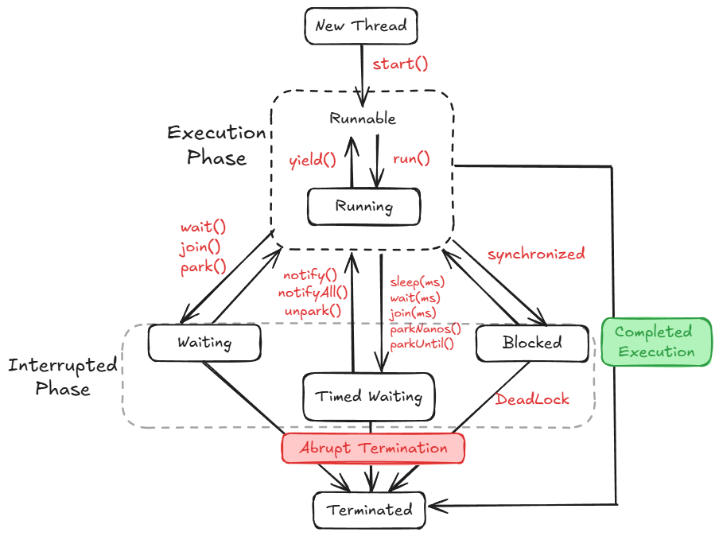

🔹

1. New Thread (New State)
- A thread object is created using new Thread(), but it hasn’t started yet.
- Transition:
  - Call start() to move to the Runnable state.

🔹 2. Runnable State
- The thread is ready to run and is waiting for the Thread Scheduler to pick it up. It’s not running yet !.
- Transition:
  - start() → Runnable
  - yield() or run() → remains in Runnable

🔹 3. Running State
- The thread is actively executing code in its run() method.
- How it gets here:
  - Thread Scheduler picks it from the Runnable queue.
- Transitions from Running:
  - yield() → goes back to Runnable (gives chance to other threads)
  - wait(), join(), park() → Waiting
  - sleep(ms), wait(ms), join(ms) → Timed Waiting
  - synchronized block not available → Blocked

🔹 4. Blocked State
- The thread is waiting to enter a synchronized block/method(Resource) locked by another thread.
- How it gets here:
  - Tries to enter synchronized code that's already locked.
- How it exits:
  - When the lock is released, it returns to Runnable.
- Special Case:
  - May lead to Deadlock if threads are stuck waiting on each other forever.

🔹 5. Waiting State
- The thread is waiting indefinitely for another thread to perform some action like notify() or join() or waiting for Thread Schedular to pick them up again for execution.
- How it gets here:
  - wait(), join(), park()
- How it exits:
  - Another thread calls notify(), notifyAll(), or unpark() on it.
- Note:
No timeout here — the thread waits forever unless notified.

🔹 6. Timed Waiting State
- The thread is waiting for a specific time (not indefinitely).
- How it gets here:
  - sleep(ms)
  - wait(ms)
  - join(ms)
  - parkNanos(), parkUntil()
- How it exits:
  - Time runs out or
  - It is notified/unparked early

🔹 7. Terminated (Dead) State
- The thread has completed execution or terminated abnormally.
- How it gets here:
  - run() completes successfully → Completed Execution
  - An exception or forced stop → Abrupt Termination

🔹 Abrupt Termination
- Thread is killed or stopped due to some problem or an unhandled exception, or external interrupt/kill.(using sleep() for long time, interrupt(), stop())
- Leads to:
Terminated state.

Sr.No | State | Trigger/Method | Description
1️⃣ | New | new Thread() | Thread object created
2️⃣ | Runnable | .start() | Ready to run
3️⃣ | Running | Scheduler picks it | Now executing run()
4️⃣ | Blocked | Enters locked synchronized block | Waits for lock release
5️⃣ | Waiting | wait(), join(), park() | Waits until notified/picked again by Thread Schedular
6️⃣ | Timed Waiting | sleep(), wait(ms), join(ms) | Waits for limited time
7️⃣ | Terminated | run() ends or crash | Thread dies
🔄 | Runnable ↔ Running | yield() | Ready to running and vice versa
🚨 | Any → Terminated | Uncaught exception or kill signal | Abrupt stop due to some problem

- Imagine a food delivery app like Swiggy:
- 🧾 Order created → New
- 🚴 Delivery person assigned → Runnable
- 🏍️ Out for delivery → Running
- 🚦 Stuck at red signal → Blocked
- ☕ Waiting at restaurant → Waiting
- ⏲️ Waiting for OTP → Timed Waiting
- ✅ Order delivered or canceled → Terminated

Synchronization in Multithreading:

- When multiple threads try to access a shared resource(single resource) simultaneously being unaware of each other’s operation on the shared resource, leads to data inconsistency or undesired output(race condition).

- This is because multiple threads will try to access a single resource, resulting in race conditions, both executing together without waiting for each other!!!

- The above problem in multithreading can be overcome using synchronization concept.

Synchronization:
- It is the process using which we can achieve data consistency(accuracy) in multithreaded environment. It can be achieved using synchronized keyword.

- “synchronized” keyword can be used only with the blocks.

- Whenever a thread gets an access to a synchronized shared resource then the lock will be applied on that resource so that no other thread can get access to same synchronized shared resource.

- This lock will not be released until and unless the currently executing thread (which has the access on the synchronized shared resource) completes its execution.

There are two types of locks:

1. Class lock: If the synchronized shared resource is static in nature, then the lock applied on it is called as class lock.
2. Object lock: If the synchronized shared resource is non-static in nature, then lock applied on it is called as object lock.

Method used for synchronization

- wait () : It is a non-static method present inside Object class. Which is used to pause the execution of currently executing thread. This method must be used inside synchronized block.

- notify () : It is a non-static method present inside Object class. Which is used to resume the execution of paused thread on the same shared resource.

- notifyAll() : It is a non-static method present inside Object class. This method is used to resume the execution of multiple threads whose execution has been paused on the same shared resource.

Deadlock in multithreading:
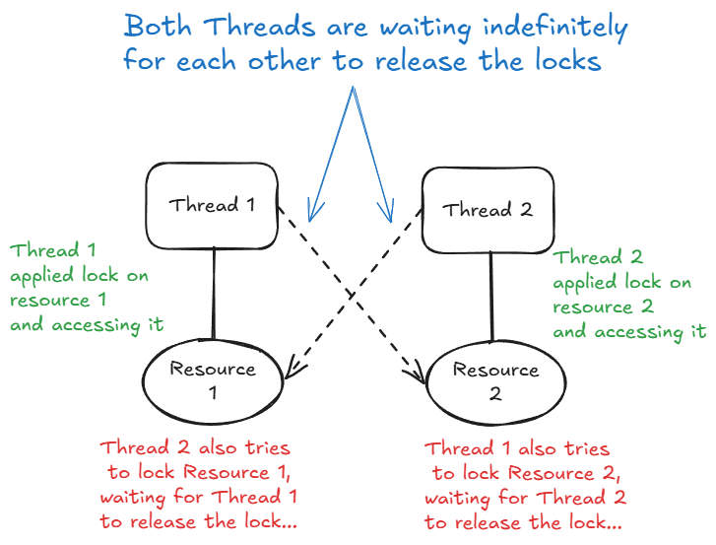

- In the given diagram, we are dealing with two threads and two shared resources, both of which are synchronized. Let’s denote them as:
- Threads: T1 and T2
- Resources: R1 and R2
Step 1: Thread T1 locks Resource R1
- Thread T1 starts its execution.
- It successfully acquires a lock on Resource R1.
- This means no other thread can access or lock R1 until T1 releases it.
Step 2: Thread T2 locks Resource R2
- At the same time, Thread T2 also starts executing.
- It successfully acquires a lock on Resource R2.
- Now, R2 is locked by T2, and any other thread (including T1) trying to access R2 will have to wait.
Step 3: Thread T1 tries to lock Resource R2
- After locking R1, Thread T1 attempts to lock R2.
- However, R2 is already locked by Thread T2.
- So, T1 is put on hold — it will wait until R2 is released.
Step 4: Thread T2 tries to lock Resource R1
- Similarly, after locking R2, Thread T2 attempts to acquire a lock on R1.
- But R1 is currently held by Thread T1.
- As a result, T2 is also put on hold, waiting for R1 to be released.
Step 5: The Deadlock
- Now, both threads are stuck:
  - T1 is waiting for T2 to release R2.
  - T2 is waiting for T1 to release R1.
- Neither thread can proceed because they are each holding one resource and waiting for the other.
- This results in a deadlock, where both threads are indefinitely waiting for each other to release the required locks!!!.

Daemon Threads :
- Daemon Threads are low priority threads which will be started by the JVM itself after regular interval of time.

- A programmer cannot control the execution of daemon threads. Along with that a programmer cannot see the execution of daemon threads.
- Daemon threads will be executed in the background during the run time of an application.

- We have some inbuilt Daemon Threads as well as a user can also define customized Daemon threads.

- The popular inbuilt daemon thread in java is Garbage Collector.

- Garbage collector is a program (Daemon Thread) which will be executed over a regular interval of time by the JVM to search for garbage (de-referred objects) inside the heap memory and removing them from the heap memory which leads to efficient utilization of the heap space.

